What is reverse causality and how do I prevent it?
Reverse causality flaw is when information is justified as being important because of another piece of information that requires memorisation.
This can create a closed loop between the two pieces of information whereby remembering why something is important depends on rote-learning the reason.
Ultimately, it defeats the purpose of the relationship or chunk, because instead of helping your memory by making things more logical, it adds another item for you to memorise.
For example, consider a topic with 5 concepts: A, B, C, D, and E.
If we say that A is important because it is needed to create B, this relies on memorising the fact that A creates B in the first place. It does not connect A with any prior knowledge or any concepts outside of just A and B. This is the closed loop.
In the illustration below, notice how the only connection that we can create is an arrow from A to B, and this arrow would have to be memorised because there is nothing else that we can use to logically infer the importance of A, except that it creates B.
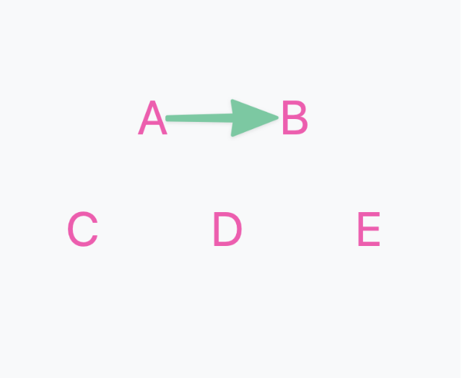
The alternative would be, for example, to justify the importance of A because of its influence on C and D, and that it is created by E. This connects A with C, D and E. When we then learn that A creates B, B now exists in the context of a wider network.
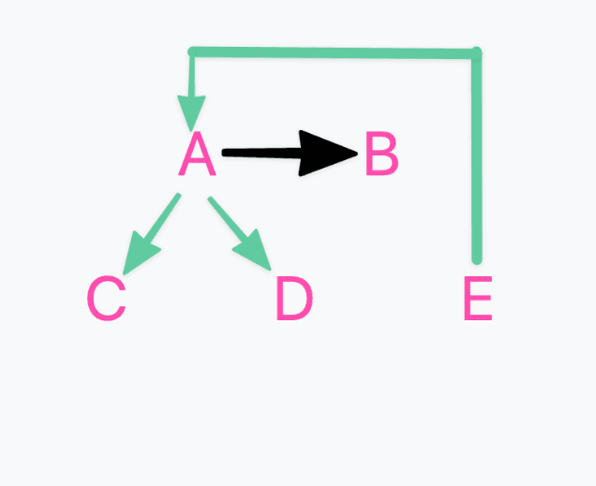
Note that intuitive chunking can help to prevent reverse causality. Importance checklisting or Simple question and answer can increase it.
Checking for reverse chunking
A quick check for reverse chunking is to make the statement:
“___A_____ is important because ______B_______”
Then ask yourself
“Would I only know that if I memorised that B is due to A?”
If the answer is yes, this means that the importance of A is justified through rote memorisation, rather than leveraging prior knowledge and other relationships within the topic.

